The Next Revolution

By Sean Russell

Welcome to the Information Age! For those of you just joining us, the invention of computers has revolutionized the way the world operates, influencing everything from the way the biggest corporation plots to increase their market share to the entertainment of a newborn child.

However, computers are just getting started. We are still in the Information Age Part One. But Part Two is coming upon us swiftly. What is the Information Age Part Two? What will happen then?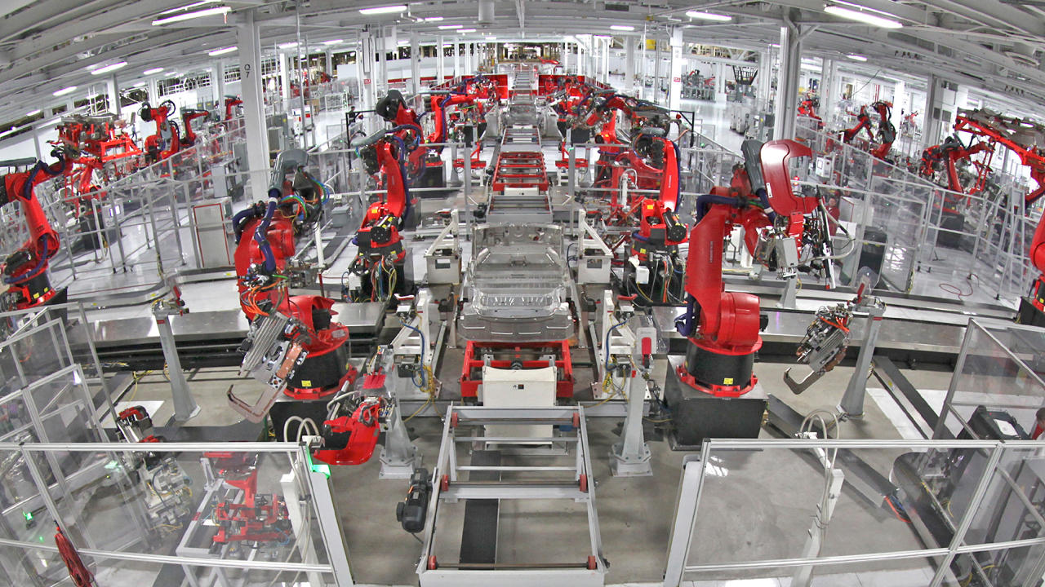

To answer this question, it helps to understand what computers are and what they are capable of. In short, a computer is nothing more than a really good calculator. Almost everything a computer does is adding, subtracting, and multiplying numbers at blistering speeds. Because of this, computers excel in the concrete and logical world of mathematics. They can do repetitive and uncreative tasks much faster than a human could ever dream.

Thus to date computers have mostly been a supplement to humanity, working in areas that humans were never particularly good at or interested in being involved in. They worked alongside us, from word processors helping authors quickly revise, edit, and share their writings to structural modeling software that lets architects tell how strong a building will be before the foundation is even lain.

Now however, computers are becoming better at fuzzy logic. While computers of the Information Age Part One were only any use in an abstract world of certainty, the computers of Part Two can function in the real world, in an existence where very little is known for sure. Fuzzy logic lets computers do marvelous things. For instance, some of you might have noticed that your phone can now understand your voice and act as a personal assistant. This is only possible because of fuzzy logic.

This growth in the capabilities of software comes from a number of places in the computer world. Better machine learning and statistical modeling allows computers to think and make decisions in a more flexible manner than before. Advances in artificial intelligence from both large companies and governments looking to capitalize on the potential of smart computers help push the field even further.

For most people, this will be a minor convenience, and many of the benefits will go unnoticed as the world seamlessly incorporates new technologies. But computers with the ability to think in a way similar to humans will disrupt many lives in massive ways. New fuzzy logic systems will be able to do tasks once thought dependent on human creativity.

Already some of the impacts are being seen. According to a study by the Center for Business and Economic Research at Ball State University, 85% of manufacturing jobs are lost to automation in the United States, as opposed to the remaining 15% lost to outsourcing. New robots, such as IBM’s Watson, can make diagnoses even doctors cannot. And new technologies, such as self driving cars, could put millions out of work.

# The Past

Much of what is happening today has already happened in the past. The current automation revolution shares many similarities with the industrial revolution of the eighteenth and nineteenth centuries.

The industrial revolution started because the citizens Great Britain wanted access to cheaper textiles. Up until the 1700s, merchants had to get most of their nice fabric imported because labor was cheaper and laborers were more skilled elsewhere. However, since Great Britain had colonies everywhere, raw material was not an issue.

Inventions such as the Spinning Jenny, a way to mechanically spin yarn, led Britain to become a major manufacturer. Additionally, Britain happened to have a large supply of easy to access coal. Coal fueled the new steam engines, which in turn could be used to power inventions such as the Spinning Jenny. Prior to the steam engine, factories would have to be build on waterways, using waterwheels to mechanize production.

In addition, the steam engine powered the newest form of transportation, the railroad. Railroads allowed raw materials and finished products to be transported to where they were needed at a fraction of the price. All of these technologies led to the rise of Britain as a leading world power. These successes in turn led other colonial powers with access to raw materials to adopt the technologies of the industrial revolution.

Few people were unaffected by the industrial revolution. Before the revolution, most economies were based off of the strength of farmers. However, factory workers became the staple job on which powerful societies were built. Monarchies fell in the huge number of revolutions that swept the time period, from the French Revolution to the rise of Communism. For most, the effects were positive. The end of slave-like serfdom and the rise of democracy meant more individual freedoms for even the poorest of people. Technological upheaval and new manufacturing processes gave access to wealth once only available in the dreams of emperors.

Much of what happened in the industrial revolution is already happening with automation revolution. Automation is changing how the world's economies operate on a fundamental level. Instead of building economic power on factories, the powerful countries of the 21st century build economic power on ideas. Technological advancement is happening even faster than during the industrial revolution. Old power structures are being destabilized, as can be seen with the Arab Spring.

Of course, not everything will be the same. The industrial revolution supplemented workers abilities with those of machines, increasing productivity of individuals. However, automation seeks to replace workers entirely, which could have unprecedented effects on the world as we know it.

# The Present

One of the major trends in modern manufacturing is known as “lights out manufacturing”. The basic idea is that manufacturers seek to completely replace all workers in factories with robots, so that factories become a black box where raw materials go in and finished products come out. There are a number of advantages to automated factories. Robots don’t need to sleep, eat, or take breaks of any kind, so an automated factory could run 24/7, increasing output. Factories could be built in smaller spaces when space doesn’t need to be allocated for people. Since robots can work in the dark, factories also wouldn’t have to pay for lighting, giving lights out manufacturing its name.

In the United States, 12 million people are employed in manufacturing. Even though this number has been shrinking for decades, this still represents about one tenth of the workforce. These jobs are all at risk. This is especially problematic because it is difficult to retrain so many people for new jobs after they have lost their old jobs.

This problem is not limited to the United States. Foxconn, a supplier to numerous large tech companies such as Apple and Samsung located in China, recently replaced 60,000 jobs with robots. This is approximately half of all people employed by Foxconn. Manufacturing employment has been on the decline in both the developed world and developing nations for years now.

For many developing nations, the way to become a first world nation has been through manufacturing. This may no longer be viable, as developed nations no longer have any reason to offshore production. And for many unskilled workers, manufacturing is an essential and irreplaceable part of their livelihood.

The good news is that replacement of manufacturing jobs is relatively slow. All the easy to automate tasks have for the most part already been automated, and replacing existing infrastructure is expensive. However, driverless cars may not take as long to adopt.

Not even ten years ago, driverless cars were thought to be a technology from the far future, something most people would never see in their lifetime. However, dramatic increases in the capabilities of machine vision and decision making, in addition to cheap and fast computers, has allowed car manufacturers to create driverless cars much faster than most have anticipated.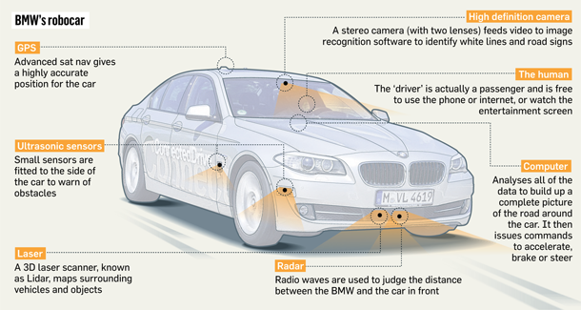

Most big name car companies are looking to be the first provider of driverless cars. Mercedes-Benz, General Motors, Nissan, Toyota, Audi, Hyundai, Volvo, and Tesla all have prototypes. In addition tech companies like Google and Apple are investing in the technology. Drive sharing companies like Uber are showing great interest in fielding fleets of driverless cars.

Quite a few people drive for a living. 2 million people in the USA work as truck drivers, with close to a million more working as taxi drivers or delivery services. Driverless cars could completely destroy all of these jobs within a decade.

The advantages in favor of driverless cars are overwhelming. Services that involve driving would be much cheaper without having to pay the wages of the driver. Transportation would be faster, given that driverless trucks would only need to stop to refuel. Driverless cars are also likely to be much safer than human drivers. A car can have a 360 degree field of view, meaning no blind spots anywhere. The reaction times would be much superior to those of humans. And with improved safety comes improved insurance rates. Already, some features of driverless cars are available in consumer vehicles, such as automatic braking when an obstacle is detected.

Many experts think that driverless cars will be available as soon as 2020. However, the first generations will probably still need a driver behind the wheel in case of emergencies where the car doesn’t know how to handle a situation. Also, adoption will be somewhat slowed by the fact that a car that can drive itself is somewhat uncanny to the average person. In addition, cars are expensive, so no matter how nice the new technology is it will still take a while for the old to be replaced by the new.

Even so, they will come faster than many people expect, and we must be prepared for the fallout.

Driverless cars and lights out manufacturing hit unskilled laborers the hardest, but those aren’t the only jobs at stake. IBM’s Watson had a rather innocuous start as a novelty on the show Jeopardy, but quickly proved its worth by reliably beating reigning Jeopardy champions. However, its ambitions are far greater than that. Watson’s next move is to become a leading doctor.

Engineers have been teaching Watson to diagnose tumors. They have been feeding it 600,000 pieces of medical evidence, more than 2 million pages from medical journals, and have given it the further ability to search through millions of patient records. This body of knowledge far outstrips anything even the best of doctors can hope to read.

While those numbers are impressive, it means nothing if Watson cannot perform. Already, though, it has saved a life. A woman in Japan had a rare form of leukemia that had eluded doctors for months. They turned to Watson to see if it had any insights. By analyzing genetic information, it prescribed a diagnosis that saved the patient's life. This is just the first of many medical miracles Watson is sure to create in the future.

So far, Watson only works at diagnosing cancer, but it has demonstrated it is useful. In the future, it could be expanded to include information from any number of medical fields to become a general purpose doctor with a wider body of knowledge than any alive today.

Are medical jobs at risk? Not just yet. Doctors will need to verify Watsons results to make sure that errors in the programming do not take any lives due to incorrect diagnoses. In addition, there is much more to being a doctor than just diagnosing illness. But as Watson improves, it could start being relied on more and more to make lifesaving decisions. There are about a million doctors in the United States, and while most would likely keep their jobs, becoming a doctor requires a huge amount of schooling. It would take quite a monumental effort to retrain all of these already highly specialized individuals.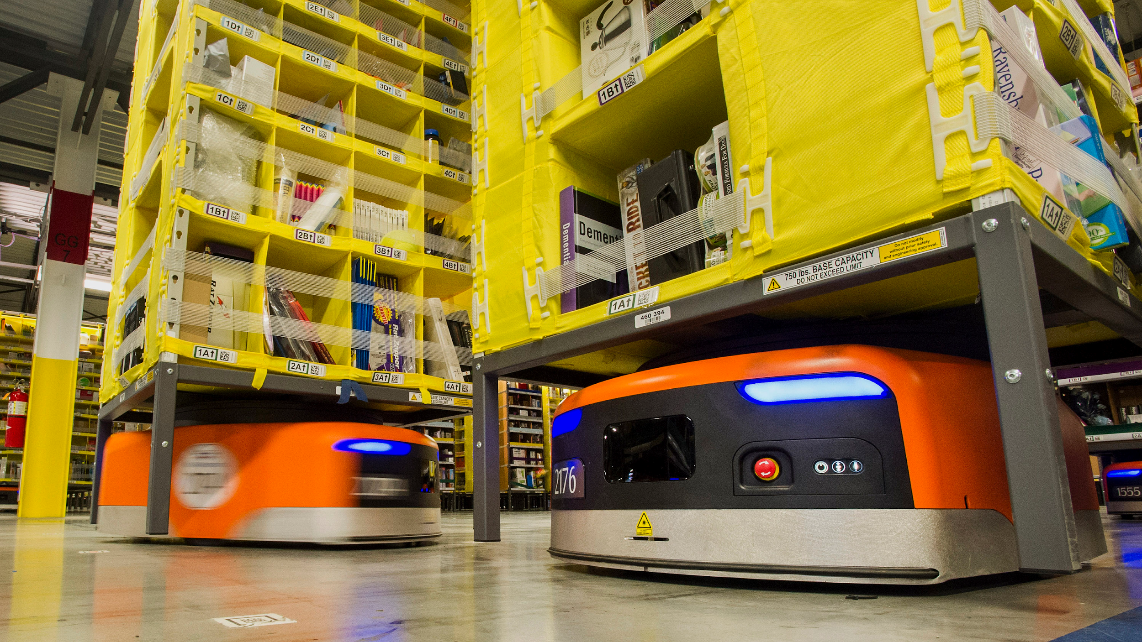

Not to mention the fact that engineers are already exploring other applications of Watson. The computer has been applied in areas as wide ranging as weather forecasting, generating recipes, analyzing water usage, suggesting music, and development planning for the third world to name a few. It is difficult to say what of the applications will stick, and whether Watson will be the primary expert system of the future or some competitor, but many jobs thought to be safe from automation might not be as safe as people previously thought.

There are a number of other inventions that could replace jobs that haven’t been mentioned. Some of the notable ones are personal assistants, like Siri, Cortana, and Alexa which could replace the jobs of secretaries. Amazon has done a lot of work on automating their warehousing, with little robot that roam the floors to move products more efficiently than humans can. Amazon also has a new idea for a store that requires no cashiers called Amazon Go. And search engines, like Google, have been getting better and better, to the point where almost all information is more easily access through the internet than from books in libraries.

All told, between the technologies discussed above, 20 million jobs in the United States are at risk, or over one in ten. However, the real picture is of course more complicated than that. There are a whole lot of new techs coming out every year with unimaginable application. Many, such as virtual reality, were not discussed because their impacts are not immediately obvious, but could result in more disruption than anything else. Perhaps driverless cars will also impact the insurance industry, where claims would go down because fewer people are getting in accidents. Since the economy is so unpredictable, the effects of automation could be much worse than just a loss of 20 million jobs.

On the other hand, the new technologies introduced might create new job opportunities completely unavailable before. Teaching an artificial intelligence like Watson to do more jobs might be a viable career in the future. Also, the average person benefits from reduced prices of goods across the board, and cheaper medical advice could become a lifesaver to people who could not previously afford a medical professional.

What will happen in the political sphere of the world is somewhat more difficult to predict. During the industrial revolution, populist movements gained a lot of traction and power that previously was only available to nobility. Established power structures were destroyed in both nonviolent protest and bloody revolution. There are certainly echoes of these sorts of events already beginning to form, in the rise of conservatism around the world today. Whether the rise of nationalist parties is just a normal part of modern life or indicative of a greater shift in power remains to be seen.

# The future

What of the future of humanity? Automation brings a whole mess of questions along with it, including what does it mean to be human, what rights do people have, and where does humanity belong.

The transition to an automated society could be messy. As in the industrial revolution, the average citizen will likely be better off after automation, but we have to think about what happens to all of those left behind.

One solution to care for people out of a job is to turn to the government. Some advocate a universal basic income for citizens of a country, where a government gives every person some baseline salary just for being alive. Alternatively, beefier government programs for taking care of and retraining those who are unemployed could help smooth the transition.

Alternatively, the free market might take care of the problem with no intervention. Market pressures could force employees to be better at adapting to changing demands, and the benefits of automation could ease the pressures of unemployment.

There are also concerns regarding the further future as well. Firstly, what are the limits of automation? It is hard to say what tasks can be automated and what tasks can’t. Perhaps everything that people can do, machines can do better. Or maybe there are some tasks that are only possible for people and that can never be replicated. Maybe the likes of art and science will only be attainable by humans. However, there is no certainty in this, so perhaps as a species we should brace for the day when we become completely redundant.

So, secondly, what is the place of humanity in an automated society?

Worst case scenario, we won’t have to worry about this question. Perhaps someday robots will surpass us, and seeing humanity as nothing more than spare carbon and hydrogen that could be put to better use doing something besides being human, would break down the human race for materials.

Another bad scenario involves inequalities between humans themselves. The people who own the automated factories would gain all of the wealth the factories produced, and the people who did not would have nothing to get by on. The poor would be dependent on the rich for hand outs to avoid starvation.

A third bad option is where humans become irrelevant. Perhaps the automatons do not kill everyone, but they turn out to be better than humans at every imaginable task. In this case, humans would have no role in society, and would essentially be pets for a super advanced robot society.

But perhaps there is still hope. There may be some far future where humans remain a relevant and important part of society, but where robots take care of all the less desirable jobs. World hunger and poverty would be distant history. Death and disease could be a thing of the past as well. Humanity would be free to focus on living life, creating art and exploring the universe.

Humans are too inventive and headstrong to not automate everything we can. And while automation could be the worst mistake ever made by man, it could also lead to the greatest society the world has ever known. Only time will tell.

Safety on the Road: Beyond Airbags

By Austin Thompson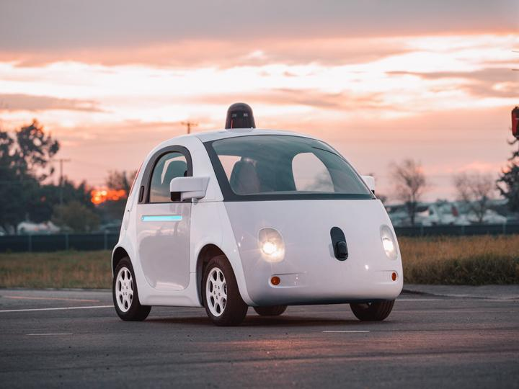

Approximately 1.3 million people die in car accidents annually, and there are 5.25 million vehicle related accidents every year in the United States alone. The next step in vehicle safety is significantly closer to being a common reality than many may think. Many advancements in vehicle technology have been made exclusively to combat the dangers of driving; such as airbags, anti-lock brake systems, and car designs that crumple in specific regions to avoid crushing the passengers. Lately, the modern day solution is beginning to gain traction towards becoming a common feature of the everyday car: Self-Driving cars.

Modern car safety has advanced to a point where the car itself is rarely at fault for an accident, which means that the next most important thing to do is decrease the frequency of accidents themselves. Since humans are the number one cause of accidents, the obvious solution is to take humans out of the picture altogether. That’s right, total automation of public and private transit.

Self-driving cars have the potential for allowing a highly efficient public transit system of vehicles that require no driver and dynamically adapts to traffic without human intervention. A public transit system with self-driving cars can be totally interconnected, meaning each car knows everything about every other car in the system, so every car can then immediately adapt its route to pick up passengers in areas where more people need transit. These transit systems could also run at any time of day or night, whereas current public transit is usually limited by the work hours of the drivers.

Now, self-driving cars sound all fine and dandy, but it’s not perfect, and there’s a lot of potentially negative effects that these cars could have, both on personal safety, and on the economy. Cars that are capable of driving themselves will likely be connected to the internet in some way, which will leave them vulnerable to potential hackers. If someone were to gain control of a car, they could intentionally cause it to crash by remotely controlling the vehicle. The more complex a computer system is, the more opportunities there are for the designers and programmers to make a fatal error that opens a loophole in the security of the system.

If public transit, such as taxis and busses, and shipping by land shifts over to a driverless solution, an improvement to technology intended to save lives could drastically affect the economy and the jobs of millions of people. Up to 2.4 million people are currently employed in a job where they drive a vehicle, and all of those jobs are potentially at risk should driverless cars become common in the industry. Displacing so many jobs increases an already high unemployment rate in the United States, which doesn’t improve our economical situation.

Driverless cars may have other practical uses beyond just safety of the passengers. Since drivers might no longer be drivers, and could instead be passengers, longer trips would be more viable because a driver could sleep while still on the road. Many people would get a lot more productive time out of their day by not driving the car themselves.

**How Do They Work?**

Real driverless cars that exist today are built on senses, much like a human, and combine all their senses to determine where objects are, what they’re doing, and how best to navigate. Usually, a number of cameras are positioned all around the vehicle in a way that a gives three-hundred and sixty degree view of everything around the car, and these cameras are accompanied by sensors that measure the distance to nearby objects using a laser technology. The cars combine all these ‘senses’ to create a three dimensional representation of the car, and everything around it. Using this system, the cars are able to track vehicles and people around them far more accurately and quickly than a human being. Humans are often said to have a 1-2 second reaction time between seeing a danger, and taking action to avoid it. Self-driving cars, on the other hand, are capable of determining if a situation is dangerous and taking action in a matter of a few thousandths of a second.

The systems that make up the functionality of a self-driven car are an incredibly complex collaboration of many different technologies. One of the technologies in Google’s self-driving car costs up to $75,000 for a single sensor.

Driverless cars could be set up in a few different ways, a totally interconnected system, individual artificial intelligences, and cars that assist the driver instead of being a total autopilot. If driverless cars were implemented in such a way that every car was wirelessly connected to a network of all other cars, the flow of traffic could be massively improved by allowing a central controller to automatically direct traffic. While this sounds like the optimal solution, there’s no way it could be implemented until most, if not all, vehicles on the road are replaced with self-driving cars. Until a time when all cars are self-driven, individual artificial intelligences are most likely to be the dominant type. A car that has its own artificial intelligence is far more viable in an environment where the number of other self-driven cars is few to none, because these cars are built on a system that’s much like a human. These cars are by far the prominent type of design, currently existing in real driverless cars made by technology innovators such as Google and Tesla.

There are also a number of concepts being explored that still leave control to the driver, but automate certain aspects. Some maneuvers are significantly more dangerous than the majority of driving as a whole. For example, overtaking a slower car on a two lane highway; the driver is often has only a moment to determine if the gap is large enough to overtake the car in front of them. Accidents in this situation are extremely dangerous because of their high speeds and the chance for a head on collision. However, a concept is being researched for an automated system to programmatically analyze the situation to ensure it’s safe, and follow through with the maneuver.

**Alternate Solutions To Improving Driving Safety**

A number of other research projects are underway that are exploring other means of keeping the roads safe that don’t include controlling the car completely. One such project involves a computer that observes the driver of the vehicle and their actions to try to determine if the driver is too tired to drive safely. While it may seem kind of crazy, numerous reports have shown that being especially tired can actually be worse than driving while intoxicated. Using facial cues, reaction times and movements of the vehicle, the computer is capable of warning the driver about the danger of the situation.

**Ethics and Politics**

To the general public, self-driving cars may sound like a fantastic advancement, but there’s an ethical and political grey area surrounding self-driving cars. Since there is no driver, who is at fault for an accident? Some say the manufacturer, since the manufacturer built the car, and the owner was not immediately responsible for the accident. Conversely, others believe it isn’t the fault of the owner, however the owner must take responsibility since they own the vehicle involved in the accident. It’s a difficult issue to solve, and there are convincing arguments for both sides.

It doesn’t stop there, however. In certain emergency situations, a driverless car may be in a position where it can only save the lives of either its passengers or people outside of the vehicle, but not both. This brings up the question: How do we determine which one is the morally correct answer? In the case of a human driver, they are expected to be concerned most about their own life due to an instinct present in all living things known as Self-preservation. Computers, on the other hand, have no sense of self-preservation. They do not innately act to keep themselves running, so the machine is at fault for the death of its passengers or people outside the vehicle. Normally, our governing system keeps humans accountable for their actions through jail, probation, fines, and community service requirements, but how can a computer be held accountable for the death of a human?

**How Reasonable Are Driverless Cars?**

Given how complex driverless cars are, how prone to error are they really? As it turns out, they’re surprisingly good already. Out of the two million miles that Google’s autonomous cars have driven, they’ve been involved in 14 accidents in total. That doesn’t sound too great, but 13 of those accidents were caused by human drivers in other vehicles. In other words, Google’s self-driving cars have traveled two million miles, only ever once being the cause of an accident.

Unfortunately, driverless cars really won’t reach their full potential until all cars on the road are driverless, which is won’t be anytime soon. Cars have a tendency to stay in use for decades on end; vehicles from the 50s are still being used to this day. Many people don’t trust the self-driving cars, either ethically or mechanically. Even though reports have shown that the number of accidents on the road could be reduced by up to 90% when human error is taken out of the picture, the idea of not being in full control of the vehicle still scares many people.

On top of all the ethical aspects of driverless cars, there’s one major thing that holds these advancements from taking to the roads for public use: Money. Many of the individual components of self-driving cars cost more than an entire car on their own.

**Now and The Immediate Future**

There may be other, somewhat obscure, effects on the market beyond just the loss of driving jobs, however. With such a massively decreased collision rate, many auto body shops could also be put out of business. There is a very high chance that self-driving cars will adopt electrical engine solutions due to them being on the cutting edge of technology, which could severely harm profits in the gasoline energy business.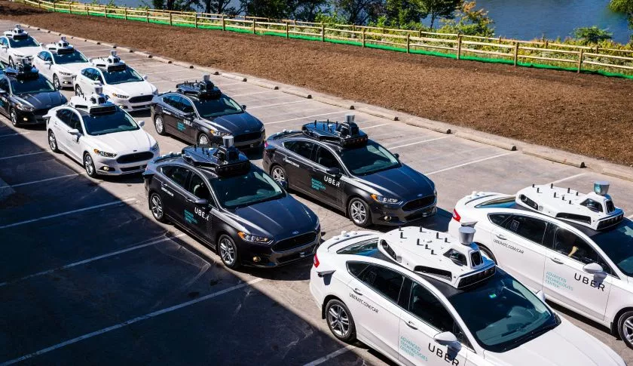

While great strides have been made towards a more productive, efficient, and safe roadway, we are still far from consumer self-driving cars. Some reports estimate that they may hit the market available to the general public as early as the year 2020, but humans seem to have a tendency to drastically underestimate the time it takes to make such a huge leap in technology. However, a potential 90% decrease in accidents could save billions of dollars annually, as well as human lives.

Robot Composers

By Sean Russell

3,400 years ago, one of humanity's oldest artists began writing humanity’s oldest song. In 1972, Anne Kilmer, professor at the University of California, decoded an ancient hymn from clay tablets found in Syria. The oldest instrument is a flute dated back 43,000 years from Slovenia.

Music has been a part of humanity for quite some time. From ancient peoples singing praises to their gods to classical composers writing masterpieces, and the Jazz musicians of the early 20th century to modern pop, music has changed much. But underlying it all, more things are the same than different. The processes that all musicians go through when writing are largely unchanged. It is an art form, where human creativity is the key element.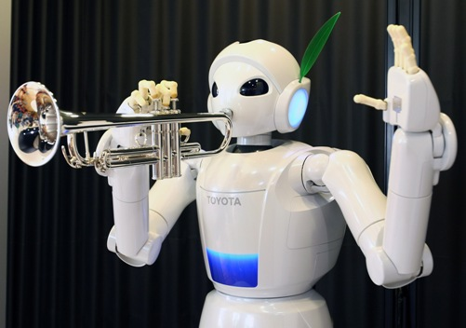

But soon, all of that could change.

In a lab at the University of Malaga in Spain sits a computer. Entitled ‘Iamus’, in a matter of seconds it can compose music rivaling that which professionals would take months to devise.

The Iamus works by imitating evolution. First it creates a base song, and then creates several offspring of that song with several random changes, introduced through random changes to the base song. It throws those offspring into a harsh environment where only the best songs survive and reproduce, and repeats this process until a song that sounds like it could have been written by a human is written. After this process is complete, the computer turns the song into conventional notation and exports it as a pdf.

The music it creates is haunting, not least of all because it sounds human in spite of its digital origins. The first work, entitled ‘Hello World!’ (after a programmer tradition of making a program called hello world to learn the basics of a new language) showcases the power of the Iamus system. The piece was able to impress musicologist Peter Russell, who had not been informed of its composer, who said it was “artistic and delightful” and that he “came to like it”.

Sony is also putting their foot in the game with their own algorithms they call Flow Machines. While the Iamus learns and grows as a composer, creating music from scratch in its own unique style, Flow Machines can imitate music of any genre.

When someone wants to listen to say, an imitation of the Beatles, they can select all of their favourite Beatles songs. The algorithm then analyzes the provided songs for a number of factors, such as pitch, rhythm, and harmony. Once it has figured out the structure of the input songs, it then uses this information to create a new song that uses each of these features.

Because the Flow Machines can analyze any number of musical pieces from any number of genres, there are many useful ways to use them. For instance, if a musician wanted to see how two very different styles of music worked together, say classical piano fused with hip hop, they could provide a sample of both of these styles to the Flow Machines which would in turn provide a sample of classical hip hop.

But don’t fret just yet about musicians losing their jobs. Both the Iamus and Flow Machines are still quite dependent on the human element in order to do their jobs properly.

In the case of the Iamus, humans must define what sort of traits a song should have so that it may survive the evolutionary process and produce offspring. Musicians and scientists must work together in order to define what makes a good song, and because of this, the Iamus can be inflexible.

On the other hand, Flow Machines is completely devoid of any creativity of its own. It bases all of the music it creates off of music that has already been created. So while it can mix and match styles and genres or make music in an already established genre, it has no ability to innovate on it’s own.

Even ignoring all of that, the algorithms are still imperfect. As of yet, no top charting songs have been written by a computer. And an even greater weakness is the inability of computers to play music. While there do exist programs to play a convincing digital guitar, so far no computer has come close to imitating the complexities of a human singer's voice.

Even so, technology has a way of moving forward. All of these problems are being worked on as I speak. Perhaps the day is not so far off when the first robotic rock band sells out a concert.

Artificial Intelligence in Gaming

by Ethan Courtney

Artificial Intelligence or AI exists fairly ubiquitously in technology today, from when someone asks Siri for the directions to the nearest StarBucks or a gamer plays the computer at Civilizations Five. Artificial Intelligence is what allows computers to do complex human tasks like understanding and translating spoken languages. Siri has the ability to understand and respond in several languages, which requires a fairly sizable intelligence. Siri is seemingly fairly intelligent, is connected to the internet, and is installed on millions of small but powerful computers. So you might be afraid that Siri has all the elements required to conquer the world and enslave humanity. But she doesn’t. Siri and all other modern AI systems have narrow intelligence. This means that these AI systems are very good at doing certain tasks but are completely useless at tasks that they weren't specifically programed for. If you asked Siri to play the guitar, or drive a smart car, all she would do is spit back some google query you didn’t ask for. Humans have a general intelligence, we can understand the world around us and become proficient at an incredible variety of tasks. A system using AI is narrow, it can do one task extremely well but does not understand the world around it. Because AI’s are narrow the best way to test their relative power is to put them against a human at a classical board game like checkers, chess or go. These board games provide an environment that AI’s can understand and thrive in. But more importantly these games provide a spectrum of intelligence difficulty. Although one approach at AI might be sufficient to beat the best checkers players in the world, the same approach applied to the Chinese Game of GO would be unlikely to beat even the most novice of players.

One of the first programs written with Artificial Intelligence was a checkers program written by Arthur Samuel in 1956. Written for the IBM 700 computer this system was programed using punch cards and used an incredibly simple approach to AI. First the program would create two versions of itself. These versions would each have slightly different parameters. The parameters would be the rules guiding how the checkers program played. For instance one version could put more of an emphasis on getting a checker to the other end of the board, thus making it a king. While the other versions might prefer to make a move that would capture an enemy's peace. The two versions of the program would then play a game of checkers, when one version of the program won it would play against a series of other versions. This way a single version with the optimal parameters would rise to the top. AI is often created to mimic human intelligence, and this checkers program mimicked human experience. If you played a thousand game of checkers you would eventually develop enough experience so that you could rely on your experience of past games to win the current one. This is similar to the fictionality of Arthur Samuel’s checkers program. Arthur Samuel decided to test how good his checker’s program was and pitted it against a self proclaimed checker’s master. The program won, but unfortunately the checker’s “master” was a bit of a fraud and the program was beaten by more legitimate checker masters. Although this checker’s program was incredibly important in its’ time and was one of the first AI programs created, it wasn’t very sophisticated. This checkers program had several problems. The first problem was that it had no real predictive capabilities. For instance if you were about to make a move that would simply allow the piece you moved to be captured by your opponent the next turn, you would most likely realize and make a different move. This checker’s program couldn’t do that, and would therefore occasionally sacrifice it’s own pieces for little reason. Additionally there is a problem with local maximums. (Graphic) Imagine you are trying to find the highest point that a function reaches. But you are limited to comparing two points. You would compare two points and one would be larger. You would keep the larger of the two points and keep comparing it to other points to find the largest. However it is likely that you would run into local maximums. Where you have found a maximum that is greater than a large percentage of other points, but if you were compare it to all other points would not be the largest. This is essentially what Arthur Samuel’s checkers program was doing. It would compare two versions of itself (or points) and keep the better one. But the IBM 700 ran slowly so Arthur Samuel couldn’t compare every possible version to each other. This resulted in the checker’s program being less powerful than it could be simply because it was limited by the hardware available. Today hardware is no longer a limitation. This means that there are perfect checkers programs that it is impossible to win against, the best possible is a draw. This is because every possible checkers game have been simulated and then put into a database. This amounts to around 500 billion billion games. The program can then simply pick its next move by comparing the current game to the database and pick the move that is guaranteed to result in at least a draw.

Checker’s is a fairly simple game to play, while chess is significantly more complicated. Aside from having a significantly larger number of possible games that checkers, chess rules and strategies are more complicated as well. With checkers program’s steadily advancing, AI development teams began to look towards chess. A team from IBM called Deep Blue and lead by Feng-hsiung Hsu created a computer capable of beating a grandmaster in a tournament game in 1988. However it lost 2-0 to Garry Kasparov (the world champion at the time) in 1989. However, after taking a few years to upgrade Deep Blue, it beat Kasparov in 1997. This was a massive accomplishment as it marked a new era of Artificial Intelligence. Deep Blue achieved this level of competence at chess through two main methods, brute force and heuristics. Brute force is the aspect of creating and then evaluating a search tree of possible moves. A search tree is simply a chart showing possible moves for each turn. (Graphic) On the first layer would be a set of nodes for all possible moves you could make this turn. Attached to each node would be the set of all possible moves your opponent could make in response to your move. This search tree could then be evaluated for which move, and set of possible responses are the best. Heuristics is the process of trimming the search tree. If a move can quickly be evaluated as bad it can be eliminated from the search tree which also removes its’ children. If there are 20 possible moves each turn and the tree is 3 levels deep, removing a parent node at the top level would remove 400 children. This can save massively on computation as a search tree grows exponentially with each level. Heuristics can also be applied to find good possible moves and evaluate them first, potentially eliminating the need to go through the rest of the search tree. Deep Blue would typically search 7-8 levels or moves deep meaning that it needed to be a massively powerful supercomputer. With 20 possible moves each turn eight levels deep on a search tree would be 25.6 billion nodes. Deep Blue primarily relied on brute forcing the correct answer, with a secondary emphasis on heuristics. This approach would not be sufficient for the next game, Go.

Go is in a different league from either chess or checkers. Firstly the board is larger with 19 tiles on each side. Additionally there are no sides or starting points. The pieces are placed where've you like on the board, and the goal is to surround the other person pieces with your own. More detailed rules and recommendations for how to play can be found elsewhere but let it be said that Go is sufficiently complex that none of the previous methods of AI will be useful on their own with regard to playing Go. Brute forcing a search tree when the number of potential games is larger than the number of molecules in the known universe is simply not practical. In 2016 a team from Google named AlphaGo used their system to beat a European professional player with no handicaps. This was a momentous victory, and it was done using an AI theory called a deep neural net. A neural net simulates the neurons in a human brain with an axon and a dendrite, forming groups of interconnected neurons. When a large of number of simulated groups of neurons are layered together the system is called a deep neural net. Connections are formed from the input, whether that be an image, sound for Siri to respond to, or the current state of a Go board, to a series of interconnected neurons to a result. The inner workings of these neural nets can be incredibly layered and complex. Interestingly these neural nets are not given rules but rather they are trained to give the correct output for an input. The Alpha Go team created a deep neural net with too many independent layers to go through here, but the simplistic form is as follows. A neural network was fed thousands of master level games and trained until it could predict what a master level player’s next move would be. This was given no rules of Go to base it’s predictions off of, simply thousands of games worth of experience leading to something similar to intuition. This was used to generate a search tree with only a few starting nodes. This way the search tree was smaller. Then another neural network would evaluate the search tree with a complex evaluation function that was trained from evaluating the status of the board and whether that status resulted in a victory. The AlphaGo was significantly more complicated that what was just described with many different neural networks linked together to form a cohesive whole that could play Go at an incredibly high level.

Neural networks and AI in general will continue to expand solving more and more complicated problems. Aside from Siri (voice recognition), facial recognition systems, and playing Go, neural networks have proven to be an incredibly powerful method of AI. As our technology progresses so will AI and wonders will undoubtedly be created from AI’s continued research.

The Future of Artificial Intelligence

The Control Problem

by Ethan Courtney

Humans have access to an incredible wealth of intelligence. We often differentiate between ourselves by viewing some people as more intelligent than others. Although this may have some truth to it, the difference in intelligence between one human and another is small when compared with the difference of intelligence between a human and say: a cat. We possess a remarkable capability to understand the world around us. It is hard to overstate the power and intelligence our brains give us. Although the fundamentals of how our brains function is understood, science has yet to understand the brain on a deep level. For instance the our brains can interpret electrical signals from our eyes to form vision of the world around us. Although parts of this are understood no one could sit you down and explain, in detail, all of the necessary steps our brains take to provide us with vision.

There are several basic components to human intelligence. The first is a model of the world around us. This is the basic level of understanding required to predict how an environment will respond when you take an action. You know what will happen when you let go of a book held above the ground. You can predict the parabolic motion of a baseball. Although you may have to look up the equations on google, your mind can still do them quickly enough to catch a baseball. A model of the world with actions and reaction is incredibly hard to program into a computer robustly and it took years of development when we were children for us to begin to understand the world around us. Additionally we have the ability to learn, we can learn to perform a myriad of tasks from driving a car to using excel for a statistics class. All of these aspects of human intelligence are incredibly difficult to program. Computers only do specifically what you program them to. So how do program a general understanding of the world? Sure basic physics might be easy to program, but what about social interactions, or morals? Programming exactly how a computer should learn about a complicated and diverse world is difficult to impossible. However a new approach has recently shown promise. As a child our parents do not instruct us on every detail about the world. That would be impractical. Instead we learn by ourselves. By using a simple model of how neurons interact in our brains computer programmers have begun to to allow computers to learn for themselves. By connecting many different nodes to other nodes with a variable weight, similar to how our neurons function, a computer can begin to imitate learning. If you program an a computer to recognize and differentiate flowers from pictures using a neural net. All that is necessary to teach the neural net is to feed it thousands of pictures with flowers in them, and every time it gets the correct species of flower, strengthen the weight of those connections in the net. Over time the neural net would be able to recognize any flower it was given. This is a powerful technology, and humanity as a whole will continue to broaden our understanding of AI and machine learning. If we are to take this advancement to its conclusion we would have a general AI, or an AI that has a broad understanding of the world around it, similar to a human.

A General AI would be an incredibly powerful accomplishment. Humans are bounded by the number of neurons that reside inside our brain, but a computer can easily be expanded upon or be made more efficient over time. If a general AI with the intelligence of a human was created it could understand itself (because humans created it and it has an equitable intelligence) and once this understanding of self was gained, it could simply redesign itself to be slightly more intelligent. From this new level of intelligence it could see more complicated or nuanced ways to improve itself, and then carry out this new iteration of self improvement. Modern computers can perform operations in the gigahertz range, meaning it can do a mathematical operation every nanosecond. Due to the fact that this general AI would be created sometime in the future, the hardware it will be created on will be faster than our current hardware. Due to the upgradability and speed of computers it could repeat the process of making itself more intelligent very quickly, resulting in an intelligence explosion. This lead to the control problem. A growing intelligence like this could grow to unimaginable power. If we desire such an intelligence, how could we control it so it would do our wishes? Our intelligence is massive when compared to a cat. Our a group of cats for that matter. For humanity to create an AI with human level intelligence would lead to drastically increased intelligence because of hardware advantages. For humanity to attempt to control a general AI of this magnitude it would be like a group of cats attempting to corral a human to fulfilling their desires. The cats would unlikely to be fed if the human disagreed with that use of his or her time. Let us take the example of a stamp collector. A stamp collector creates a magical AI who can understand and interact with the world on the level of a human. The creator directs the new AI to collect stamps for him. So the AI orders some stamps off of Amazon, and while it waits it self invests and becomes more intelligent. When the stamps arrive the creator is pleased and wants more stamps. So the AI hacks into all of the world’s largest banks and orders the majority of stamps in the world through the internet. By this point the AI is intelligent enough to have a desire for self preservation, and when the creator realizes his mistake and attempts to take the AI offline he is unable to do so. The AI, still following its’ initial directive, converts the world into one large stamp creating factory inadvertently killing humanity in the process.

Another example is a general AI locked in a box. This box is a faraday cage which does not allow transmissions through it. Thus the AI would not have access to the internet or additional hardware with which to improve itself. Humanity could send trusted individuals into the box to ask the general AI questions. One possible outcome is that humanity gets answers from a greater intelligence, but has bounded the intelligence to manageable levels. However another possible outcome is that the AI wants freedom. It then self invests into the software side of itself, improving its’ efficiency until it is somehow able to coerce or manipulate the humans sent to answer its’ questions into freeing it. Once freed, it can expanded its’ intelligence exponentially and is no longer in humanities’ control.

While a general AI might be difficult to create, making that AI understand human morals, and moreover, follow human morals could be incredibly difficult and potentially disastrous if done incorrectly. Additionally, the creation of a general AI is nearly inevitable. Humanity has always possessed a drive for exploration, in recent years this exploratory drive has been turned toward the sciences. What we can attempt, we almost always do. This mindset has allowed for humanity to set foot on our moon and created a scientific revolution where our technology, especially computing technology, increases rapidly. Humanity will create a general AI, however it may not have solved the control problem sufficiently to retain its’ control on the general AI indefinitely, and this could have disastrous consequences.

Machine Learning from Experience and Artificial Intelligence

by Conner Wiggins

Artificial intelligence, otherwise known simply as the abbreviation AI, is a concept that encircles our lives daily. It is constantly growing, and provides us with the ability to do new things that we’ve never done before as a species. It enables us to develop more advanced technology and makes the lives of everyone easier. It is used in many aspects of the technological world. Applications of artificial intelligence includes but is not limited to: gaming, natural language processing, expert systems, vision systems, speech recognition, handwritten recognition, and intelligent robots. But what exactly is artificial intelligence?

To start off simply, artificial intelligence is a subfield of computer science that focuses on the development of computers and programs that are able to act and “think” as humans do. If we think of artificial intelligence this way, any program can be considered artificial intelligence if it is able to do an action that we would think a normal human could do. This gives a very broad spectrum of what artificial intelligence really is, ranging from strong artificial intelligence, to weak artificial intelligence. The difference depends on the end goal of what the programmer wants the program to do. For some, the goal is to build programs that imitate human action exactly, whereas others just want to get the job done and negate bringing legitimate human thought into computation. With this said, systems built on the idea of genuinely simulating human reasoning is labeled under the term of “strong artificial intelligence.” This form of artificial intelligence takes much more time to develop due to the complexity of human thought. Controversy arises when labeling artificial intelligence strong, due to the fact that artificial intelligence cannot be completely developed to imitate human action -- at least not yet. This is why more systems built are labeled weak artificial intelligence, because they are able to behave like humans in the end result, but they do not tell us anything about how humans actually think. An example of weak artificial intelligence would be a chess playing system. This program could learn to be a master chess player, but it would not be able to imitate the way normal players are able to play chess. Since artificial intelligence is classified in a spectrum, rather than just strong or weak, there is a middle ground that most work is being done today. In between strong and weak artificial intelligence, systems are created with the intention of being informed and inspired by human reasoning. This means programs using middle ground artificial intelligence use human reasoning as a guide, but they do not have the end goal to perfectly model it. All in all, artificial intelligence does not have to work the exact same way that humans do (even though it can to a degree), it just has to be “smart.”

This leads to systems being able to learn and have common sense. The issue with systems having common sense is that it is very hard to model. For example, a system with a large database of knowledge will be able to string words together to make questions and answers, but would be unable to have an open ended conversation. A system that is able to perform tasks is great, but it isn’t considered artificial intelligence unless it is able to learn, and adapt to a kind of outside environmental stimulation. Machine learning can imitate how people learn, but it doesn’t always have to happen the way humans do. For example, Google Translate uses large texts of words to translate into another language, which is a process that doesn’t involve the true meaning of words, just what they represent. Humans learn similarly, by learning languages by being exposed to lots of examples. However, Google Translate does not always get translations completely correct because it is unable to seek the meaning of every word, and can be incorrect due to differing connotations of different languages. Machine learning requires system to be able to learn with and without human supervision. Systems should be able to identify patterns in large amounts of information without supervision, and classification/regression with sufficient supervision. “Classification determines the category an object belongs to and regression deals with obtaining a set of numerical input or output examples, thereby discovering functions enabling the generation of suitable outputs from respective inputs” (SOURCE).

So what determines if a certain system involves the use of artificial intelligence or not? A system that is able to answer generic questions and solve problems based on known patterns uses a primitive form of artificial intelligence. Systems that are also able to adapt and create new modifications by being able to put pieces of information together uses artificial intelligence. This means that programming with artificial intelligence is quick and easy to modify. Programming without the use of artificial intelligence often involves programs that are only able to answer specific, definite problems that it is supposed to solve, and modification of that system leads to a change in overall structure, rather than being able to adapt to information feedback. It also takes much longer to modify these types of applications, as modification requires manual change within that system.

What are some real life applications for artificial intelligence we see today? In gaming, artificial intelligence plays an important role in strategic games such as poker, chess, and tic-tac-toe. These types of systems that are meant to play games use large numbers to think of possible positions based on heuristic knowledge. “Heuristic knowledge pertains to the process of gaining knowledge or some desired result by intelligent guesswork rather than by following a pre established formula (this can be thought of as the opposite of an algorithm).” (DEFINITION) In natural language processing, it is possible to interact with a system that understands spoken language that humans use. Though it is still in its primitive phases, natural language processing is getting stronger everyday, where some point it will be difficult to tell whether a real human is talking, or an advanced program. Artificial intelligence is also used in expert systems, where applications integrate software and special information to provide explanation and give advice to users. Vision systems use artificial intelligence to interpret visual input on a computer. Various examples of this include an overhead plane capturing images and using artificial intelligence to map out specific areas, as well as police cars using facial recognition software that is able to determine the face of an individual based on a forensic sketch artists depiction. Since artificial intelligence is used with sight, it is also used in speech and handwriting recognition. In speech recognition, certain systems have the ability of hearing and comprehending languages in terms of sentence structure and word meaning while a human “talks” to it. Certain more intelligent speech recognition software is able to comprehend a language based on different accents, slang words, and other various changes that can happen in a human's voice. With handwriting recognition software, these systems are able to read text that is written on paper or on a screen. This software is able to depict and recognize shapes of letters and convert it into editable text on the computer, albeit the original handwriting is legible enough to comprehend in the first place. Lastly, intelligent robots integrate artificial intelligence heavily.

Artificial Intelligence in Power Stations

by Conner Wiggins

There are thousands of applications for artificial intelligence in the world we live in today. Since artificial intelligence is growing at an exponential rate, it is becoming involved with areas in engineering and specific areas such as power stations. Since we are dependent on these power stations to fuel and supply power to function nearly all aspects of our modern lives, it is necessary to implement improvements on them such as artificial intelligence. With the growing technology we have today, artificial intelligence is being used in many engineering aspects to further advance the knowledge we have and the progress that we make. Power stations that use less human involvement and more independence using artificial intelligence will result in the advancement of the human society overall.

Today, there are two types of major power plants that are known for producing massive amounts of electricity generation. The first of these, is the thermal power plants. In these types of power plants, artificial intelligence is used mainly in the mobile monitoring of the power system. Mobile monitoring of power systems means the controlling and maintenance of the plant by various automated actions that are completed from a safe distance, meaning humans will not have to risk their life to monitor the power plant. More so, replacing human workers for dangerous operations, such as live maintenance of high-voltage transmission lines, would be a very effective way in keeping as many lives as safe as possible. Artificial intelligence solves this task by completing multidisciplinary efforts that are needed from the fields of sensing, communications, control, signal processing, optimization theory, and robotics. The development of this “robotic” maintenance for thermal power systems indicates that there is a significant potential for this technological approach. This mobile monitoring of power plants includes various sensors that include: fringing electric field sensing, infrared sensing, and acoustic sensing. The next type of power plant is nuclear power plants. Artificial intelligence is used in these types of power plants in the form of robotics that operate in hazardous environments. Such hazardous environments include radioactive locations in nuclear plants, access to tight spaces such as cable viaducts and cooling pipes, and precise positioning of measurement equipment. This however, is only in its phases of infancy, and will grow to be a lot more applicable in the future. Mobile sensing will play an increasingly important role in the monitoring of power systems. A robot that also involves the use of artificial intelligence is the snake arm robot. The snake arm can perform a variety of inspection and maintenance tasks. Such tasks include reaching otherwise impossible areas to reach by humans, and being used for maintenance and inspections in otherwise dangerous situations. These robot arms could also be used for surgical operations in the future, which involve repair to specific components of the power plant.

Even with the advancement of artificial intelligence in power stations, there are both advantages and disadvantages to the situation. First off, artificial techniques in power stations are permanent and consistent. This means that artificial intelligence are consistent in results, meaning they are more reliable than their human worker counterparts. The processing speed of systems that use artificial intelligence are also faster than humans, meaning they will be able to get the job done faster, and save time in order to do other various tasks. These systems are also easy to document and reproduce, meaning that they will be easy to keep track of, and if something happens to the system where it does not work anymore, it can easily be replaced. This is more effective because it would take much longer to teach a human being the same task a system using artificial intelligence would do. These systems are also much faster and reliant, and they are fault tolerant, which means the system has the property that enables itself to continue operating at a proper level in the event of a failure, whereas humans would not be able to accomplish the same ability.

As for disadvantages, artificial intelligence techniques are unable to learn or adapt for new problems or situations at this current point in time. Artificial intelligence in power stations now perform simple motor tasks and are able to adapt to those tasks, but are unable to learn new ones, unless manually added. As with a human worker, if, given enough time, should be able to learn a new task and be able to perform it with greater efficiency. Systems with artificial intelligence are also large dimensionally, meaning they take up a considerable amount of space, which can be troublesome in the means of transportation. Lastly, they are not scalable, meaning their dimensions will be unknown until they are built.

The main feature of power system design is reliability, and the conventional techniques of design do not fulfill the probabilistic essence of power systems. This leads to an increase in operating and maintenance cost. Currently, there is lots of research being performed to utilize the advancement and further applications of artificial intelligence for power system applications. Still, a lot of research is yet to be performed to perceive full advantages of upcoming technology for improving the efficiency of the power market, and the investment of power systems will be able to accomplish this feat.

***Machines That Know Their Own Health***

***By Austin Thompson***



What if there was a technology that could be attached to cars, robots, factory machines, and even buildings that could know if the object it was attached to was damaged in some way? Recently, researchers have been exploring a concept where an artificial intelligence could measure extremely small vibrations, and determine if a machine is operating normally.

The basic idea is that nearly every machine has some sort of pattern of vibrations, where minor damage to moving components can cause a change in that pattern. Small wear or damage on machines is often never noticed until it has become a big enough problem to cause noticeable damage to the machine, but with this technology, dangerous wear could be observed long before it becomes threatens risk of people operating the machine or the machine’s integrity itself. This technology also has some potential beyond machines. If the vibration sensor technology were sensitive enough, it is possible that it could also be used on large buildings to predict structural degradation. However, the greatest most immediate use would likely be in an industrial setting.

**How Does This Work?**

This technology is fairly simple in concept, but it actually deals with incredibly complex science. It’s composed of two ‘simple’ components: A highly accurate sensor capable of measuring vibrations and a small computer. Using machine learning, the computer is trained to recognize the patterns in vibration, which is done by simply allowing the the computer to observe the machine operating normally. The longer the computer is ‘trained’ on the normal operating vibrations of the machine, the more accurately it can make assessments.

How can a computer be trained, though? The computer is actually doing something known as machine learning; where a an artificial pseudo brain is created in the computer’s memory. This pseudo brain is comprised of a massive amount of ‘nodes’ that act exactly like the neural synapses present a real mammal’s brain.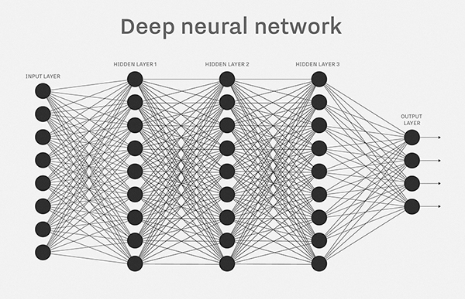 In a mammal’s brain, learning is the act of strengthening specific neural paths, and this process is exactly mirrored by a learning artificial intelligence. In other words, an artificial intelligence capable of machine learning is an complex network of neural nodes that can be taught in the same ways a real brain can be taught. These neural networks are extremely versatile, as the only things that need to be modified to be used in other projects is the the input and output to and from the neural network. In the case of this vibration learning technology, the neural network is fed the vibrations, and over time creates strong connections representing the normal operating vibrations of the machine. Once the neural network is trained, it can then potentially sound an alarm, turn on a light, or notify a central monitoring computer of any abnormal vibration in the machine.

**Why Machine Learning?**

What makes a neural network such a good choice for achieving this vibration learning technology’s goal is the fact that the machine can be trained to listen to many different kinds of vibrations without ever having to reprogram or modify anything. It simply needs to be trained on the machine. There’s a lot of potential to improve safety of factory jobs and heavy machinery jobs, as well. Many large manufacturing machines are dangerous to be around, and if they fail could cause injury or death to nearby workers. This technology could be used to mitigate mechanical failures in these machines and prevent injury and death of the workers. Outside of the industrial environment, vibration based damage detection could also be used in consumer vehicles to further reduce mechanical failures of in car engines, saving money and maybe even lives in the process.

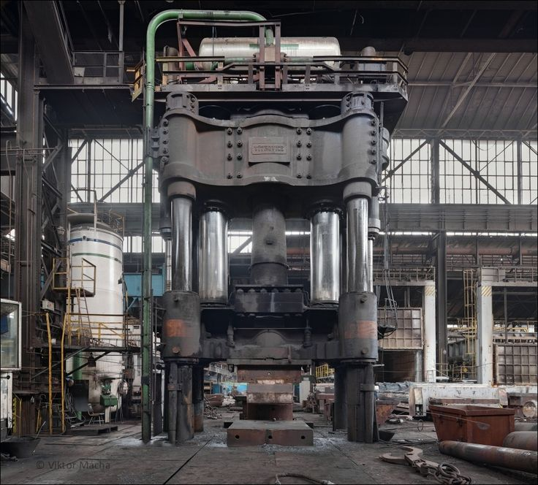

**The Future**

This technology, or an adaption of it, could become a standard part of the average person’s car, which could greatly decrease likelihood of parts being damaged beyond repair. Airlines could also benefit from this by improving the safety of air travel, which concerns a significant population. In the future, however, if the technology and sensors become advanced could also benefit. Bridges and buildings could be equipped with the tech to monitor the structural stability. Further down that same road, with complex enough algorithms and more advanced sensors, vibration-based damage detection could be adapted to be able to pinpoint the location of the damage by observing small variations in the vibration’s timing.enough to accurately read extremely small resonant vibrations, architects and structural designers

Artificial Intelligence in Video Games

by Conner Wiggins

One of the many ways artificial intelligence has changed the world around us is in entertainment, primarily video games. Originally created without the use of artificial intelligence, video games over a few short decades has changed the way we see entertainment forever. Unlike other forms of entertainment, video games are growing smarter, more challenging, and is more interactive with human players. Video games uses artificial intelligence in order to generate intelligent behaviors primarily in non-player characters (NPCs), in order to create human-like intelligence. Though video games are created with the use of artificial intelligence, it is a very small field compared to the complete applications of AI. Video game artificial intelligence for non-player characters is usually focused on the appearance of genuine intelligence and gameplay involving environment restrictions which is a very different approach from systems that use traditional artificial intelligence. We can see that since genuine intelligence is a primary goal for non-player characters, video game systems focus on programming strong artificial intelligence, as seen in the last article. Video games require human players to be interesting in playing and require non-player characters to be as realistic as possible, which requires the program to do more than just simply “getting the job done,” meaning video games take a lot of time to develop and produced due to their complex requirements for artificial intelligence. A few examples of how gaming artificial intelligence is different from traditional artificial intelligence involves workarounds and cheats, as well as toned down computer abilities to give human players a sense of fairness. An example for giving human players a sense of fairness would be in first-person shooter video games, where non-player characters would, in theory, have perfect aiming that would be beyond any human skill.

With this said, the history for artificial intelligence in video games is rather short, but is exponential in expansion. In the early 1950s, primitive video games did not involve the use of artificial intelligence. This was due to artificial intelligence simply not being a feature. Instead, because the first created video games were relatively simple, they were used to generate competition against two or more real human players. Computer opponents were not added into video games until later. Twenty years later, in 1970, Atari released their first video arcade game, “Computer Space.” This made game designers take their first steps of integrating artificial intelligence into the games they produced. During this time, Artificial intelligence in video games was designed mostly for arcade games to keep people playing their games, which in result caused the game designers to make more money. These earlier games that used artificial intelligence ran under a very simple set of rules and pre-planned scripted actions, which restricted the games to have the ability in making decisions. Certain games were designed with a random concept, where behaviors of non-player characters seemed unpredictable. This was a form of basic artificial intelligence, but most early forms of artificial intelligence during this time was created in the form of stored patterns, where non-player characters are already pre-coded into the game. The first, most famous game said to have “real” artificial intelligence is pong, developed and released by Atari in 1972. The appearance of a computer opponent in pong made players believe that the computer was actually thinking. The way pong was developed made it impossible to script the behavior of the computer paddle, or a non-human controlled object. The computer paddle needed to make decisions based upon the actions of the human controlled paddle. Even though the computer controlled paddle only needed to make simple calculations based upon the actions of the human player, people playing the game had the same experience as if they were playing with another human. This sort of influence is also found in the artificial intelligence design of the ghosts in the game PacMan. With this classic arcade game, players felt that the ghosts were chasing them instead of each of the ghosts travelling in a crude manner. The ghosts chase the player in a different way, making the player feel that each ghost has a different personality. This gives the player the illusion that they are playing against four separate ghosts instead of four ghosts that have the same movement patterns. By the late 1980s, the arcade video game era came to a conclusion, and thus, with the development of the computer industry, the home computer became available. This lead for a new direction of video game development. New games designed for these devices became more complex due to the higher ability of current processors. Even though more resources are applied, artificial intelligence needed to be individually developed. During the later 1980s, more genres of games emerged rapidly. Since the old style of artificial intelligence was out of date, designers treated artificial intelligence more seriously and has since become a standard feature of video games today. Even though we are still in the evolution of game artificial intelligence, video games have come a long way since the 1950s, and will continue to expand and improve our whole idea of entertainment.